AIM: To synthesize low /high pass filter using an operational amplifier, resisters, and capacitors.

PRELAB PREPARATION

Familiarize with the following topics,

1. Active and passive filter characteristics
2. Classification of filters
3. Approximation problem
4. Frequency transformation

THEORY

1. Determine, the required filter circuit arrangement from following according to your specifications and device the transfer function of the filter circuit.

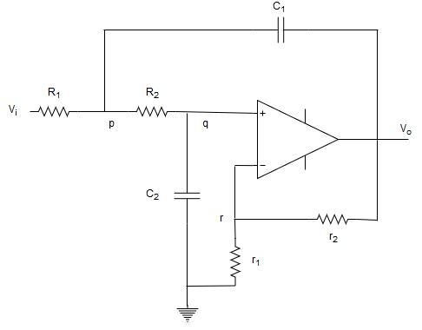

FIGURE 1: SALLEN KEY TOPOLOGY FOR LOW PASS FILTER

1. Find the amplitude and the phase response of the circuit in terms the components

Assuming ideal conditions of the op-amp in figure 1,

$$i^{+}=i^{-}=0$$

$$v^{+}=v^{-}$$

$Z_{c1}=\frac{1}{sc_{1}} and Z_{c2}=\frac{1}{sc_{2}}$

Apply KCL to node p,

$$\frac{V_{p}-V_{i}}{R_{1}}+ \frac{V_{p}-V_{q}}{R_{2}} +\frac{V_{p}-V_{o}}{Z_{c_{1}}}=0 →(1)$$

By voltage division,

$$V_{q}=\frac{Z_{c2}}{Z_{c1}+R_{2}}V_{p}$$

Since $V_{q}=V_{r}$,

$$V_{p}\frac{Z_{c2}}{Z_{c2}+R_{2}}=V_{o}\frac{r_{1}}{r_{1}+r_{2}}$$

$$V_{p}=V_{o}\left(\frac{r_{1}}{r_{1}+r_{2}}\right)\left(\frac{Z_{c2}+R_{2}}{Z_{c2}}\right)$$

$$V_{p}=V_{o}\left(\frac{r_{1}}{r_{1}+r_{2}}\right)\left(\frac{\frac{1}{sc_{1}}+R_{2}}{\frac{1}{sc_{2}}}\right)$$

$$V_{p}=V_{o}\left(\frac{r_{1}}{r_{1}+r_{2}}\right)\left( 1+sR_{2}C_{2} \right)$$

By substituting to (1) ,

$$\frac{V_{o}}{R_{1}}\left(\frac{r_{1}}{r_{1}+r_{2}}\right)\left( 1+sR_{2}C_{2} \right)-\frac{V_{i}}{R_{1}}+\frac{V_{o}}{R_{2}}\left(\frac{r_{1}}{r_{1}+r_{2}}\right)\left( 1+sR_{2}C_{2} \right)-\frac{V_{o}}{R_{2}}\left(\frac{r_{1}}{r_{1}+r_{2}}\right)+V_{o}\left(\frac{r_{1}}{r_{1}+r_{2}}\right)\left( 1+sR_{2}C_{2} \right) sc_{1}-V_{o}SC_{1}=0$$

$$V_{o}\left(\frac{r_{1}}{r_{1}+r_{2}}\right)\left\{\frac{1}{R_{1}}+\frac{sR_{2}C_{2}}{R_{1}}+\frac{1}{R_{2}}+\frac{sR_{2}C_{2}}{R_{2}}-\frac{1}{R_{2}}+sC_{1}+s^{2}R_{2}C_{1}C_{2}-sC_{1}\left(\frac{r_{1}+r_{2}}{r_{1}}\right)\right\}=\frac{V_{i}}{R_{1}}$$